[1]SymCheck: Self-Diagnosing Web Application Using Image Recognition

Alan Singleton, Briana Figueroa, Jasmine Washington, Morgan Franklin, Sayema Islam, Swapnil Kadekar *Seidenberg School of Computer Science and Information Systems Pace University, New York, NY, USA*

***Abstract*— Medical diagnosis, when stripped down to its bare-bones, fundamental underlying principles, can be seen as a process grounded in pattern recognition—a careful analysis of an instance through the lens of existing trends and data, and their subsequent classifications. And in a world where medicine and technology see a greater degree of interplay each year, a number of technological applications exist for allowing people to thus diagnose themselves of having or not having certain ailments and illnesses based on comparisons of their own symptoms to those of positive cases past. However, each of these applications has its own features and methods of delivery, and as a result also show various grades of accuracy in producing a reasonable prediction.**

**This paper offers a solution that strives to work off of and improve on its predecessors, offering a form of machine learning-based classification that closely parallels a physical medical diagnosis. In using an image of symptoms as input, and analyzing its features piece by piece before consolidating them to compare with known diagnoses to produce a reasonable result, this study produces a novel application that allows users to save time and money, while still receiving a considerably reliable understanding of what is going on in their bodies. And in doing so, the product produced strives to make its own contribution to an era that welcomes speed, convenience, and self-sufficiency.**

*Keywords*— self-diagnosis, computer science, medical imaging, machine learning, deep learning, image classification, convolutional neural network, CNN, chickenpox, varicella, pinkeye, conjunctivitis

# INTRODUCTION

SymCheck is an application that arose as the product of an everchanging world—one where people seem to get busier and busier each year, and thus show a desire to take more control of the uncertainty in their lives through a degree of self-sufficiency, as well as one taken aback and driven to ever-increasing wariness by a crippling pandemic. The idea behind the self-diagnosing web application is quite simple: create a means by which people can assess their own medical conditions *without* paying a physical visit when deemed unnecessary; for why should one expend precious time and gain exposure if a situation does not demand it? And according to SolvHealth, an acclaimed online healthcare facility locator, symptoms of [itchy] rashes, as well as illnesses such as conjunctivitis or pinkeye are only two of the most common, yet generally not life-threatening, conditions treated at urgent care facilities [16]. Thus, SymCheck was born, becoming one of the first image-based web applications for self-diagnosis capable of classifying illnesses and abnormalities specific to more than one part of the body.

The SymCheck application can be broken down into two major components: a trained machine learning-based model for image classification, and the front-end user interface. The learned model used for this study is one based on a convolutional neural network, or CNN, and it receives its image inputs for classification from uploads through a dynamic webpage that serves as the user interface, with the two being integrated via a classic client-server model. Both components will be discussed in more detail in the sections to follow, with II and III examining current machine learning studies and the specific algorithms used as well as existing applications for self-diagnosis respectively, IV giving a brief overview of SymCheck’s base requirements, V discussing the technologies used, VI detailing the [current] results of both the classification model and the user webpage, and lastly VII to provide some closing remarks.

# Literature review

Data mining techniques have been showing increasing prevalence in implementation in medical analyses around the world, including in more rural regions in the far East such as Tibet for everything from formulating association rules for sets of diseases to mining relationships in drug prescription for the same [15]. In fact, for many regions in China as well as in various other parts of the world, the existence of data mining techniques and the subsequent understanding of the relationships they show are very important in the sense that these less-urbanized regions oftentimes lack specialized doctors who can correctly identify symptoms as being akin to those of a particular illness/disease [4]. This issue in specialization can also then be extended to more urbanized regions as well, given that even in regions where people have more access to specialized medical care, these specialists are not available at convenient urgent care facilities. Moreover, a visit to a specialist generally costs more than a visit to a primary care doctor. Thus image-based classification grounded in machine and deep learning is becoming increasingly popular for certain illnesses and diseases, especially those in the skin and eyes, something SymCheck attempts to cater to [4].

According to Hameed et. al.’s study on inflammatory skin lesions, “the human skin is the largest human organ, and it acts as a barrier between the human body and microbes as well as pathogens. When this barrier [is breached] and harmful environmental elements invade the human body, skin problems originate” [5]. Thus it is no surprise that various studies exist for the classification of a number of different skin illnesses and abnormalities including, but not limited to, melanoma (both malignant and benign), measles and German measles, and chicken pox [7] [11] [12]. However, only Islam et. al.’s study speaks specifically to the [successful] identification of chicken pox, or varicella, and implements an artificial neural network or ANN based on a texture-analysis-based approach for classification, achieving an overall accuracy of 80% [7]. On the other hand, while Namazov and Cho’s study speaks to the classification of melanoma only, the two researchers employed the use of a CNN as opposed to an ANN (i.e. more layers for feature extraction), and were able to achieve an overall accuracy of 95-98% [11].

As for existing studies revolving around the image-based classification of pinkeye or conjunctivitis, interestingly enough, there are much fewer in the ophthalmic specialty as compared to the dermatological realm. And of those that exist, classification of the illness is achieved through more comparative algorithms (as opposed to breaking images down into finer features) such as K-nearest neighbors or KNN, support vector machine or SVM, and Histogram of Oriented Gradient or HOG [8] [19]. And while these methods of classification are computationally fast and less costly than a CNN, they work off of a similarity measure between *similar* illnesses. This notion is something that ought not be employed when considering two different illnesses of two different parts of the body, and when considering the costs of *misclassification* and comparison of two unrelated maladies [13].

Thus given the existing studies analyzed—all their outcomes and considerations—SymCheck becomes the first application of its kind to study the results of employing a CNN for the classification of two (and eventually more) popular, but dissimilar, ailments. And in doing so, the application both exists as a manifestation of convenience and accessibility while also creating a means for users to save both time and money.

# Current Solutions

A self-diagnosing application is an application that will help determine what illness a person may have based on their symptoms. This type of application is not one hundred percent accurate because it is a program “diagnosing” the illness, as opposed to a trained professional. Yet, self-diagnosing applications are continuously gaining popularity due to accessibility, user-friendliness, speed, and ability save a visit to a doctor’s office. Since the pandemic started in early 2020, people are rarely leaving home unless it is for essential needs/items. As more people are staying home due to the pandemic, they are less likely to go to the doctor’s office for illnesses that aren’t life-threatening. So self-diagnosing applications are a great tool for people who want a reliable diagnosis for their illness without having to see a doctor in person.

As self-diagnosing applications are widely accessible, all that is required is a user page and Wi-Fi. Depending on the user’s preference he or she can choose from several different applications to determine his or her illness. Currently, the three major solutions for self-diagnosing applications are AskMD, Mayo Clinic, and Symptomate. Each application contains unique features which can impact whether users are interested in using that self-diagnosing tool or another. For reference Table 1 portrays a simple example of how these tools are similar and different.

TABLE I  
An overview of three self-diagnosing applications

|  |  |  |  |
| --- | --- | --- | --- |
| **App Name** | **Platform** | **Upload Images** | **Other Functionalities** |
| AskMD (ShareCare) | Mobile and Web Application | No | Microphone voice feature for ease of use |
| Mayo Clinic | Web Application | No | Sidebar when to seek medical care |
| Symptomate | Web Application | No | Graphical representation of affected area |

AskMD, also called ShareCare, is a self-diagnosing tool that is available as a mobile and web application. The ShareCare application was launched in 2012 and has been providing self-diagnoses to many people ever since. Figure 1 contains a screenshot of the homepage of the ShareCare application.

Fig. 1 Screenshot of ASKMD Symptom Checker

In the box, the user types what symptoms he or she has, then he or she clicks “Search Consultations” to continue the diagnosing process [14]. The next page lists several ways the symptom could be affecting the user. Whichever one is closest to the symptom he or she has, the user can decide to click it and then he or she is directed to a login page. This is where ShareCare becomes different from the other applications. Creating an account slows the process of diagnosis down and could likely cause a user to switch to another self-diagnosing application. On the other hand, ShareCare does provide a microphone functionality and the ability to complete a diagnosis through their mobile application, providing a different user experience then the other applications.

Mayo Clinic provides a symptom checker on their homepage but states the symptom checker is not a diagnosing tool. Since this tool isn’t a *complete* self-diagnosing tool it is faster to use as compared to AskMD and Symptomate. First, the site displays numerous Adult and Child symptoms for the user to choose from. As shown in Figure 2, the homepage of Mayo Clinic’s application displays the symptoms and how many steps it takes to complete a symptom check [9].

Fig. 2 Screenshot of Mayo Clinic Symptom Checker

Once a symptom is chosen, the “Select related factors” questionnaire appears which asks to select other factors that are present with the symptom. After this step is completed, selecting the “Find causes” button navigates to the next page and displays a list of possible diseases or conditions that correspond to the symptom and other factors the user selected. Under each disease or condition the factors the user selected are displayed in bold and those he or she did not select remain un-bolded. Mayo Clinic’s application also provides a useful sidebar for when someone should seek medical attention based on his or her symptom.

Symptomate was also launched in 2012, around the same time as AskMD. Symptomate is an application dedicated solely to self-diagnosing the symptoms a user may have. As shown in Figure 3, Symptomate’s homepage allows the user to complete a normal self-diagnosis questionnaire or complete a COVID self-diagnosing questionnaire [18].

Fig. 3 Screenshot of Symptomate Symptom Checker

While completing the normal self-diagnosis questionnaire, many questions are asked about the user and his or her symptoms. An interesting addition in this section is the featuring of a graphical representation of the human body. The user can click what area on his or her body has been causing issues and then symptoms pop up to choose from based on the area selected. The questionnaire is longer than the Mayo Clinic application but provides a more thorough analysis and diagnosis. And the results from the questionnaire display a recommendation of what the user should do and provide what the application determines could be going on with the user.

As shown in Figures 1-3, AskMD, Mayo Clinic, and Symptomate all have similar web browser layouts where the user starts by inputting his or her symptoms. Then, after receiving symptom input(s), they all provide some type of possible disease or illness the user may have. Self-diagnosing applications are a new way in medicine and technology, so it is increasingly useful to come up with new features any such applications can use to improve their systems.

# Product Requirements

Our goal is to develop a self-diagnosing web application for users experiencing symptoms of chickenpox or pinkeye. This application differs from all self-diagnosing applications in that it allows users to upload images for diagnosis. SymCheck will then analyze the image uploaded and present results based on a machine learning-based algorithm. These results will then help users possibly determine their illnesses, understand more about said illnesses, and provide them with information on when to seek a doctor.

The SymCheck application requires four major functionalities to become a complete self-diagnosing application:

1. *Upload image* – Users should be able to easily locate the option to upload an image directly on the SymCheck homepage. Once the option is clicked, they will be directed to the upload image page where users will have the capability to upload an image of their chickenpox or pink eye. After the image has been successfully uploaded, it will be analyzed by a machine learning algorithm to compute the user’s results. If the user does not want to upload any further images, he or she can return to the homepage or find the nearest Emergency Room.
2. *Find nearest Emergency Room* – A “Find the nearest Emergency Room” button will allow users to be redirected to Google Maps with nearby hospitals being displayed. Users will have access to this functionality on the upload image page and the results page.
3. *Receive Results* – After users have successfully uploaded an image of their chickenpox or pinkeye and the algorithm has completed analyzing the image, the results page will appear. On the results page, the first item to be shown is the result of the image analysis containing what illness the user may have and the percentage probability of having that illness. Next, there will be more information about the illness displayed such as statistics, treatments, and/or severity. Then, the results page will contain another display about different conditions that indicate when it is best to see a doctor. After discovering these results, the user will have the options to find the nearest Emergency Room, start a new diagnosis, or return to SymCheck homepage.
4. *Send feedback* – If users have any issues or need to get in contact with our team, users will have the ability to send feedback. Once a user is in the “Send feedback” field, he or she will see information and a link to send an email to the SymCheck team. This link will redirect to an email window where the user can directly send any feedback her or she may have.

Figure 4 shows a high-level process diagram of a user’s experience when using the SymCheck application. Each bullet point signifies the features accessible within that page.

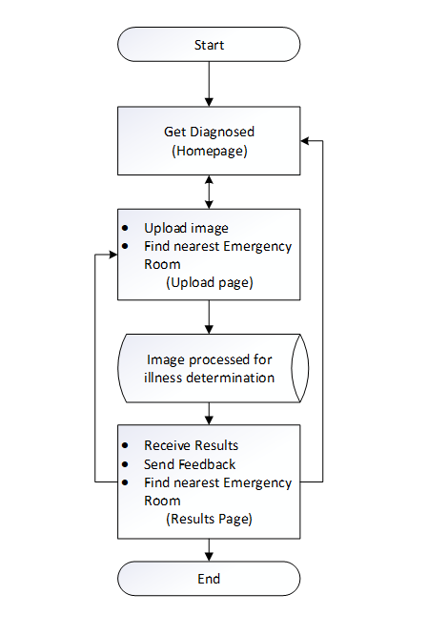

Fig. 4 Process flow diagram of SymCheck

# METHODOLOGY

The SymCheck application has been implemented in a classic client-server model. The details of the technologies used are described as follows:

1. *Client* – The frontend of SymCheck includes HTML, CSS, and Javascript. Users will be able to view and interact with SymCheck within all supported browsers.
2. *Server* - The backend of the SymCheck is implemented with Django as its web framework. And the machine learning algorithm developed has been implemented using the Keras library with TensorFlow as its backend engine. The motivation behind using this server architecture is discussed in depth in the following subsections.
3. *Django*

Django is a server-side web application framework that is written in Python. It encourages rapid development and allows for simple design of web applications [2].

Django’s architecture implements a framework called the Model-Template-View (MTV). The model layer consists of the tools used to manipulate data and databases. The view layer is responsible for taking the data provided by the model layer and transforming it into an HTTP response object to be sent to the client. And the template layer provides the user interface which generates the HTTP request and displays the HTTP response in the client’s web browser [20]. Figure 5 shows the Django framework MTV architecture.

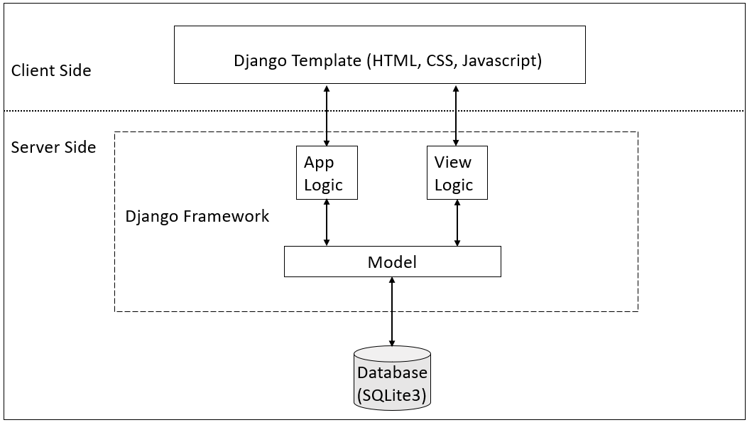

Fig. 5 Django’s Client/Server architecture diagram

1. *TensorFlow and Keras*

TensorFlow is an open source library for various machine learning models. It uses Python for its frontend API and executes applications in C++ [22]. The library can train and run neural networks for image recognition, natural language processing (NLP), and more.

Keras is a high-level API that is embedded in TensorFlow. Like TensorFlow, Keras is also written in Python and it supports multiple neural network computation engines [6]. Keras is user friendly and it provides, “out-of-the-box implementations of common network structures” [3].

1. *Why Django?*

When initially searching for a web application framework, it was important to find solutions that supported machine learning algorithms. Thus, two frameworks came into consideration: Flask and Django. Table 2 shows a comparison between Flask and Django on various attributes [17]. But it is important to note that many popular websites, web applications, and software tools have been programmed with the Django framework such as Instagram and Spotify [1]. Thus, it was due to its wider community presence and faster development speed that we chose to use Django as our web framework.

TABLE II  
A comparison between flask and Django [17]

|  |  |  |
| --- | --- | --- |
| **Term** | Flask | Django |
| **Simplicity and Flexibility** | Simpler | Hard |
| **Development speed** | Slow | Fast |
| **Size of project** | For bigger ML project | For small ML project |
| **Availability of Add-ons** | Less | More |
| **Community** | Small | Wider |

1. *SymCheck’s Image Classification Training Model*

Using the Keras API, a Convolutional Neural Network (CNN) using the Sequential model was built for the purposes of “diagnosis” on the SymCheck application. Figure 6 shows the process of image classification training followed by said CNN.

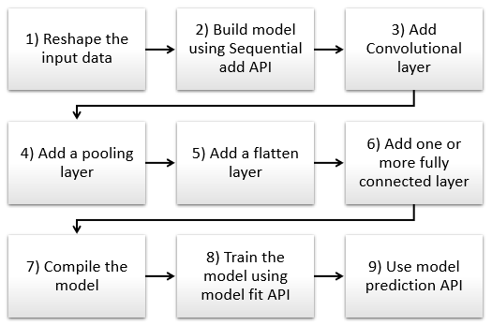

Fig. 6 Typical Process flow diagram for building a CNN architecture [10]

### Reshape the input data

The input data, or image in our SymCheck application, has to be resized into a suitable format for proper processing. Trying to analyze multiple images with varying sizes could cause the algorithm to inaccurately diagnose illnesses.

### Build model using Sequential add API

Within the Keras library, we can start building our Sequential model using the add function. Steps three through six will be parameters to add functionality for feature extraction.

### Add Convolutional layer

A Convolutional layer scans an image with a predetermined filter to extract features for classification. In our application, features would include pinkeye or chickenpox symptoms.

### Add a pooling layer

The pooling layer helps to further feature extraction by reducing its dimensionality (i.e. number of features) [10].

### Add a flatten layer

“Flattening is a technique that transforms a two-dimensional matrix into a vector that can be fed into a fully connected neural network classifier” [10]. In other words, the data is “flattened” from two dimensions to one (i.e. one long vector of features), that can then be fed into the neural network classifier.

### Add one or more fully connected layer

This step is performed to classify the images.

### Compile the model

After adding all the previous methods, we compile our model with some parameters such as an optimizer, which is a process that evaluates the input weights by comparing the prediction and the loss function, and metrics, which are used to score the performance of the CNN [21].

### Train the model using model fit API

In this step, our model will train to differentiate between normal or illness-free images vs. apparent illness images.

### Use model prediction API

Finally, the CNN will make a prediction of whether the user has an illness (or not) and provide a percentage of probability/accuracy.

# Product Results

So far, in terms of our machine learning algorithm for classification, we have trained our model to validate chickenpox with an 85% measure of accuracy. It is important to note, however, that the model was trained on grayscale images instead of color ones so this percentage may change when we finish the final training. As for the user interface to date, Figures 7 through 9 show the developed designs of SymCheck’s HTML pages.

Fig. 6 Screenshot of the homepage of SymCheck

Fig. 7 Screenshot of the upload page of SymCheck

Fig. 8 Screenshot of the results page of SymCheck

# Conclusions

SymCheck is a web application that serves as a tool to provide users with a means of self-diagnosis for common illnesses such as chickenpox and pinkeye. This application will fulfill this aim by developing a machine learning-based algorithm for image classification, that is able to feed its results directly to a user.

Future scope for this project includes adding capabilities for analyzing *textual* input of symptoms along with image analysis to produce an overall “better” prediction result. Additionally, having an artificial intelligence-engineered chat box is another feature to be considered for inclusion in the future.

References

1. “Django Tutorial for Beginners - Learn the Core Aspects of Django Framework,” *DataFlair*, 14-Jan-2020. [Online]. Available: https://data-flair.training/blogs/django-tutorial/. [Accessed: 26-Oct-2020].
2. *Django*. [Online]. Available: https://www.djangoproject.com/. [Accessed: 26-Oct-2020].
3. “5 Genius Python Deep Learning Libraries,” *EliteDataScience*, 09-Jun-2020. [Online]. Available: https://elitedatascience.com/python-deep-learning-libraries. [Accessed: 26-Oct-2020].
4. T. Goswami, V. K. Dabhi, and H. B. Prajapati, “Skin Disease Classification from Image - A Survey,” *2020 6th International Conference on Advanced Computing and Communication Systems (ICACCS)*, 2020, pp. 599–605.
5. N. Hameed, A. Shabut, F. Hameed, S. Cirestea, and A. Hossain, “An Intelligent Inflammatory Skin Lesions Classification Scheme for Mobile Devices,” *2019 International Conference on Computing, Electronics & Communications Engineering (iCCECE)*, 2019, pp. 83–88.
6. M. Heller, “What is Keras? The deep neural network API explained,” *InfoWorld*, 28-Jan-2019. [Online]. Available: https://www.infoworld.com/article/3336192/what-is-keras-the-deep-neural-network-api-explained.html. [Accessed: 26-Oct-2020].
7. M. N. Islam, J. Gallardo-Alvarado, M. Abu, N. A. Salman, S. P. Rengan, and S. Said, “Skin Disease Recognition Using Texture Analysis,” *2017 IEEE 8th Control and System Graduate Research Colloquium (ICSGRC)*, August 2017, pp. 144–148.
8. M. D. Manchalwar and K. K. Warhade, “Histogram of Oriented Gradient based Automatic Detection of Eye Diseases,” *2017 International Conference on Computing, Communication, Control and Automation (ICCUBEA)*, 2017.
9. “Symptom Checker,” Mayo Clinic. [Online]. Available: https://www.mayoclinic.org/symptom-checker/select-symptom/itt-20009075. [Accessed: 26-Oct-2020].
10. “Using the Keras Flatten Operation in CNN Models with Code Examples,” *MissingLink.ai*. [Online]. Available: https://missinglink.ai/guides/keras/using-keras-flatten-operation-cnn-models-code-examples/. [Accessed: 26-Oct-2020].
11. A. Namozov and Y. I. Cho, “Convolutional Neural Network Algorithm with Parameterized Activation Function for Melanoma Classification,” *2018 International Conference on Information and Communication Technology Convergence (ICTC)*, 2018, pp. 417–419.
12. A. Rajesh, “Classification of malignant melanoma and Benign Skin Lesion by using back propagation neural network and ABCD rule,” *2017 IEEE International Conference on Electrical, Instrumentation and Communication Engineering (ICEICE)*, 2017.
13. G. Schaefer, T. Nakashima, Y. Yokota, and H. Ishibuchi, “Cost-Sensitive Fuzzy Classification for Medical Diagnosis,” *2007 IEEE Symposium on Computational Intelligence and Bioinformatics and Computational Biology*, 2007, pp. 312–316.
14. “AskMD - Get Answers - Manage Conditions and Symptoms,” Sharecare. [Online]. Available: https://www.sharecare.com/askmd/get-started. [Accessed: 26-Oct-2020].
15. W. Shiying, Z. Lei, W. Lu, C. Nanjia, Z. Xiaolan, L. Hong, and W. Xiaoying, “Research on Syndrome Classification Prediction Model of Tibetan Medicine Diagnosis and Treatment Based on Data Mining,” *2016 12th International Conference on Signal-Image Technology & Internet-Based Systems (SITIS)*, 2016, pp. 497–502.
16. SolvHealth, “What are the Most Common Urgent Care Conditions?,” *Solvhealth.com*. [Online]. Available: https://www.solvhealth.com/faq/what-are-the-most-common-conditions-treated-at-urgent-care. [Accessed: 23-Oct-2020].
17. Shubham, “Flask vs Django: Which Python Framework is best for Machine Learning app?,” *SpiderPosts*, 10-Sep-2019. [Online]. Available: https://www.spiderposts.com/2019/06/07/flask-vs-django-which-python-framework-is-best-for-machine-learning-app/. [Accessed: 26-Oct-2020].
18. “Symptomate – Check your symptoms online,” Symptomate â Check your symptoms online. [Online]. Available: https://symptomate.com/. [Accessed: 26-Oct-2020
19. J. Tamuli, A. Jain, A. V. Dhan, A. Bhan, and M. K. Dutta, “An Image Processing Based Method to Identify and Grade Conjunctivitis Infected Eye According to its Types and Intensity,” *2015 Eighth International Conference on Contemporary Computing (IC3)*, 2015.
20. “Django's Structure – A Heretic's Eye View - Python Django,” *The Django Book*, 21-Jun-2020. [Online]. Available: https://djangobook.com/mdj2-django-structure/. [Accessed: 26-Oct-2020].
21. “Keras - Model Compilation,” *Tutorialspoint*. [Online]. Available: https://www.tutorialspoint.com/keras/keras_model_compilation.htm. [Accessed: 26-Oct-2020].
22. S. Yegulalp, “What is TensorFlow? The machine learning library explained,” *Gale General Onefile*, 18-Jun-2019. [Online]. Available: https://search-ebscohost-com.rlib.pace.edu/login.aspx?direct=true&db=edsggo&AN=edsgcl.589534891&site=eds-live&scope=site. [Accessed: 26-Oct-2020].

1.